**Tutorial 1- End To End ML Project With Deployment-Github And Code Set Up**

**Agenda—**

1. Set up the github {Repository}
2. New environment
3. Setup.py
4. Requirements.txt
5. Open the github and create an account and then create a new repository

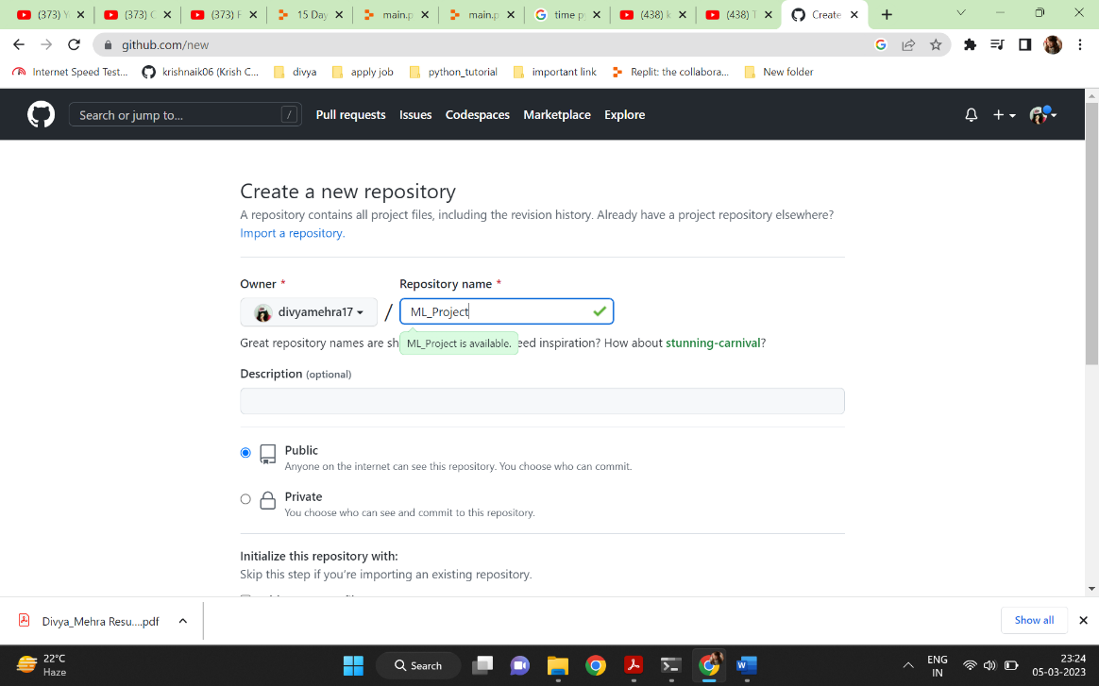

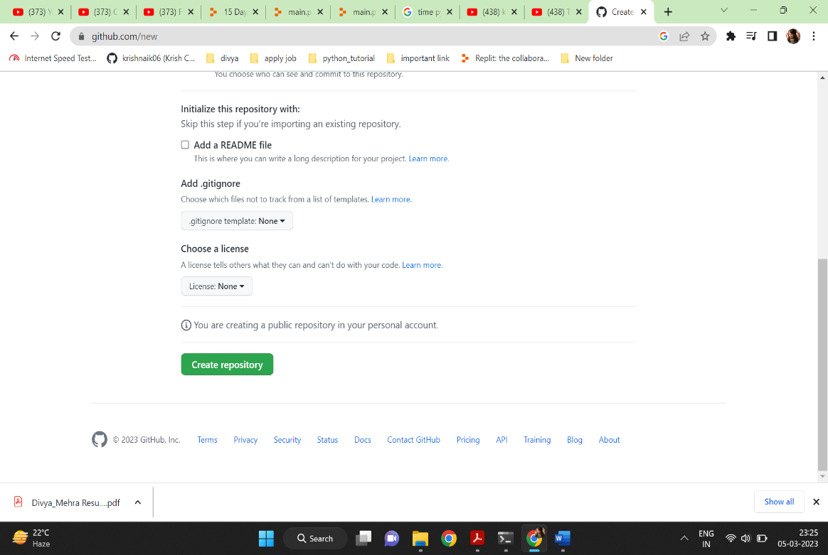

And click on create repository.

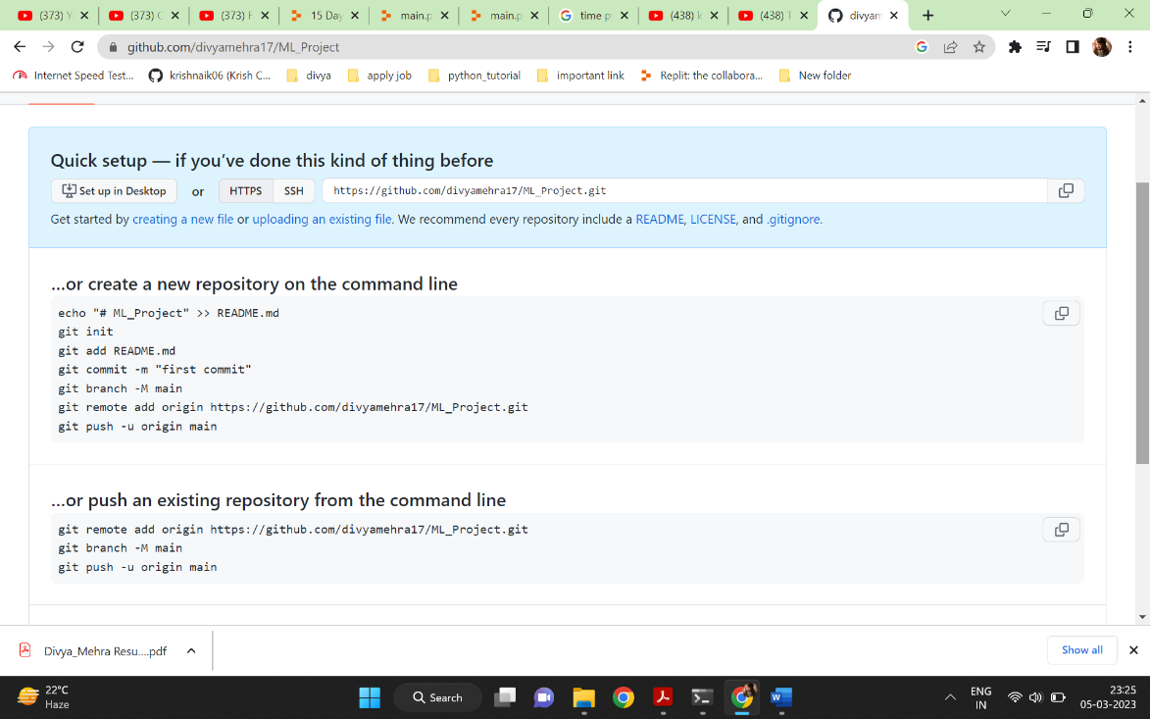

# Creating a New Environment -----

Step1: C:\Users\divya\OneDrive\Desktop\ML_Project> conda create -p venv python==3.7 -y

Step2: C:\Users\divya\OneDrive\Desktop\ML_Project> conda activate venv/

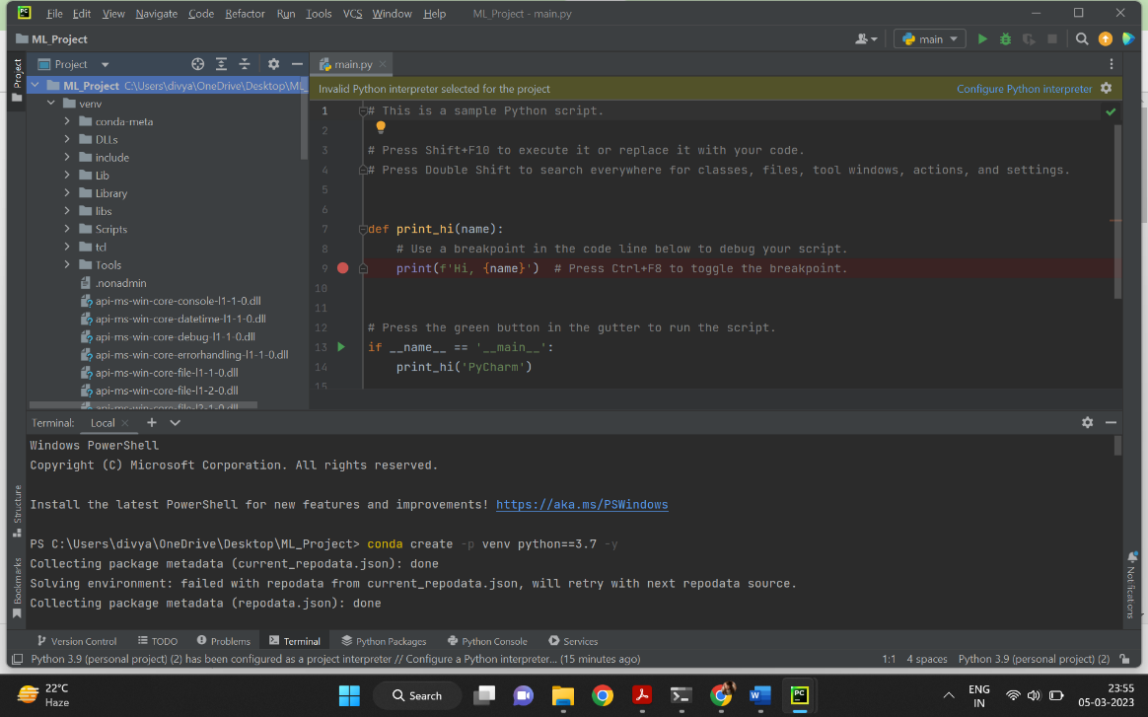

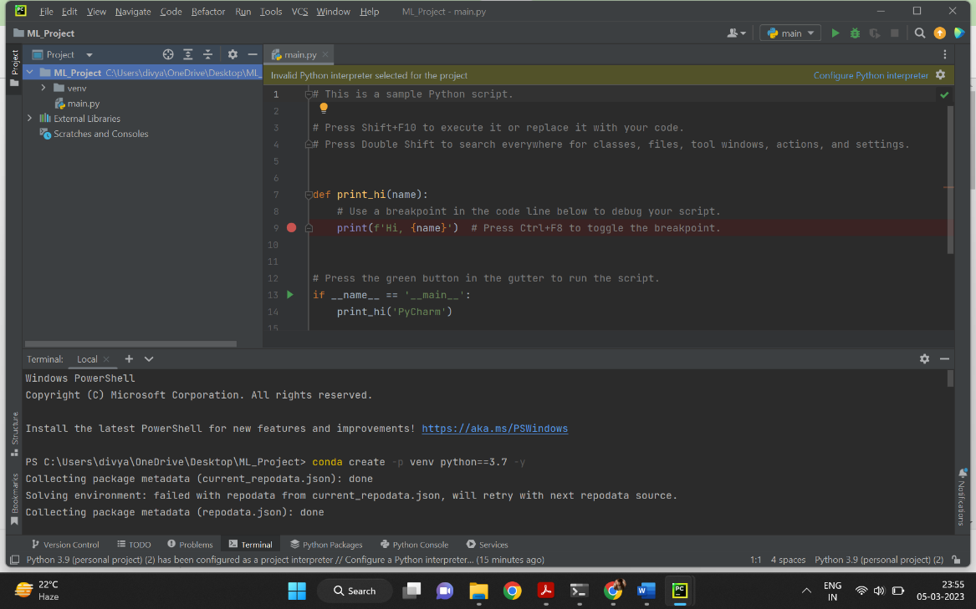

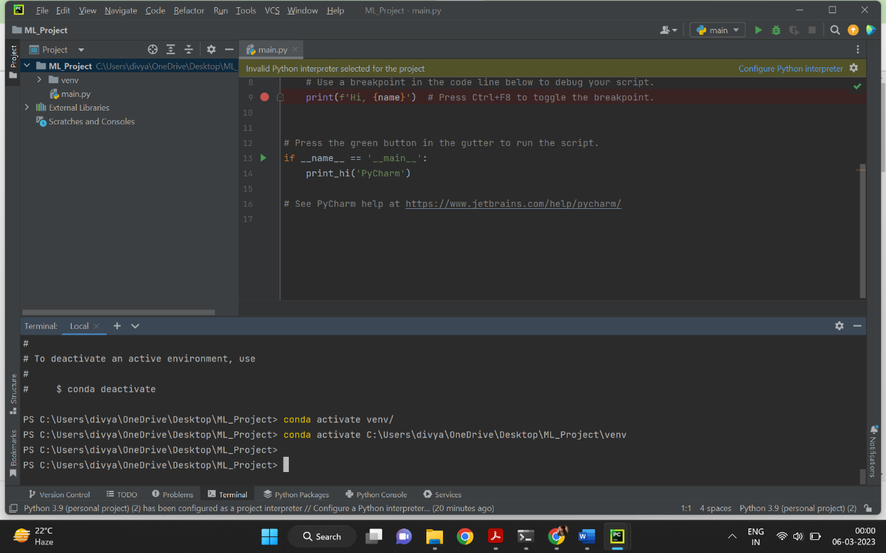

# Initializing the github repository and add readme file

Step1: C:\Users\divya\OneDrive\Desktop\ML_Project> git init

Step2: C:\Users\divya\OneDrive\Desktop\ML_Project> git add README.md

Create a readme.md

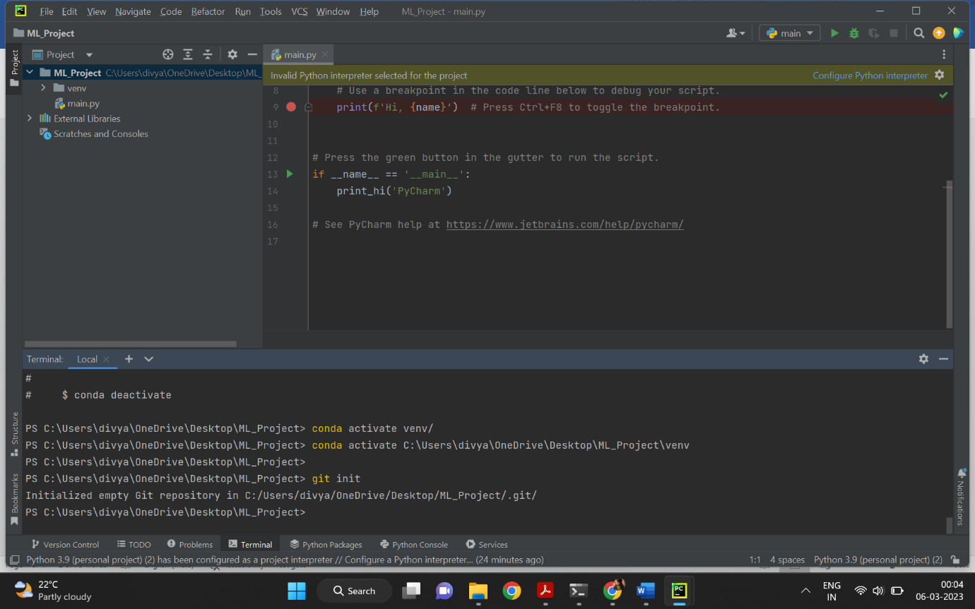

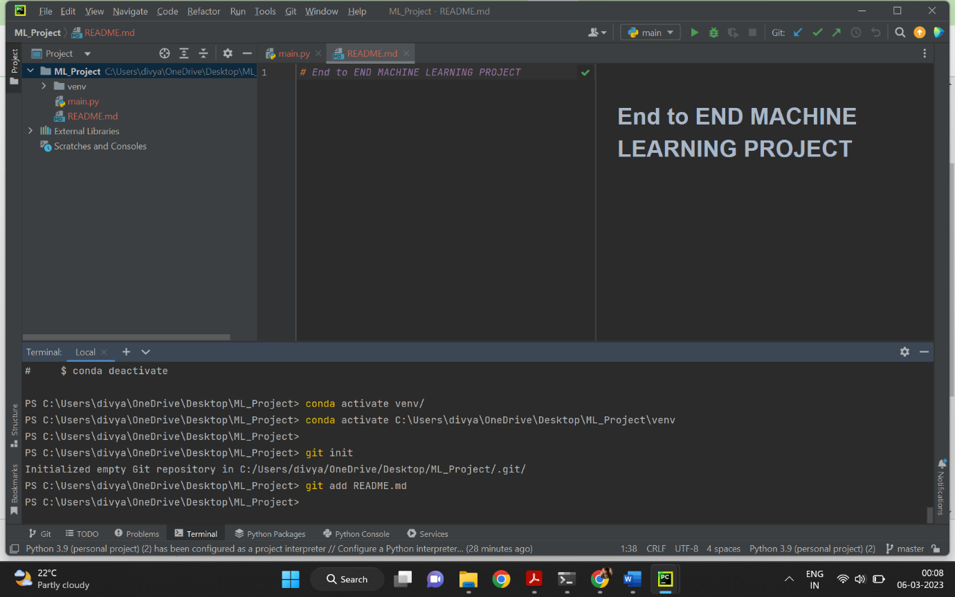

## first commit and push in github ---

Step1:

PS C:\Users\divya\OneDrive\Desktop\ML_Project> git commit -m "first commit"

Author identity unknown

*** Please tell me who you are.

Run

git config --global user.email "you@example.com"

git config --global user.name "Your Name"

to set your account's default identity.

Omit --global to set the identity only in this repository.

fatal: unable to auto-detect email address (got 'divya@LAPTOP-7U8SJN5B.(none)')

PS C:\Users\divya\OneDrive\Desktop\ML_Project> git config --global user.email "you@example.com"

PS C:\Users\divya\OneDrive\Desktop\ML_Project> git config --global user.email "divyamehra170596@gmail.com"

PS C:\Users\divya\OneDrive\Desktop\ML_Project> git config --global user.name "divyamehra17"

PS C:\Users\divya\OneDrive\Desktop\ML_Project> git config --global user.name

divyamehra17

PS C:\Users\divya\OneDrive\Desktop\ML_Project> git config --global user.email

divyamehra170596@gmail.com

PS C:\Users\divya\OneDrive\Desktop\ML_Project> git commit -m "first commit"

[master (root-commit) 4f8e350] first commit

1 file changed, 1 insertion(+)

create mode 100644 README.md

Step2:PS C:\Users\divya\OneDrive\Desktop\ML_Project> git status

On branch master

Untracked files:

(use "git add <file>..." to include in what will be committed)

.idea/

main.py

venv/

nothing added to commit but untracked files present (use "git add" to track)

Step3:PS C:\Users\divya\OneDrive\Desktop\ML_Project> git branch -M main

Step4:PS C:\Users\divya\OneDrive\Desktop\ML_Project> git remote add origin

<https://github.com/divyamehra17/ML_Project.git>

Step5:PS C:\Users\divya\OneDrive\Desktop\ML_Project> git remote -v

origin https://github.com/divyamehra17/ML_Project.git (fetch)

origin https://github.com/divyamehra17/ML_Project.git (push)

Step6:PS C:\Users\divya\OneDrive\Desktop\ML_Project> git push -u origin main

info: please complete authentication in your browser...

Enumerating objects: 3, done.

Counting objects: 100% (3/3), done.

Writing objects: 100% (3/3), 249 bytes | 249.00 KiB/s, done.

Total 3 (delta 0), reused 0 (delta 0), pack-reused 0

To https://github.com/divyamehra17/ML_Project.git

* [new branch] main -> main

branch 'main' set up to track 'origin/main'.

# Creating a .gitignore file

Step1:

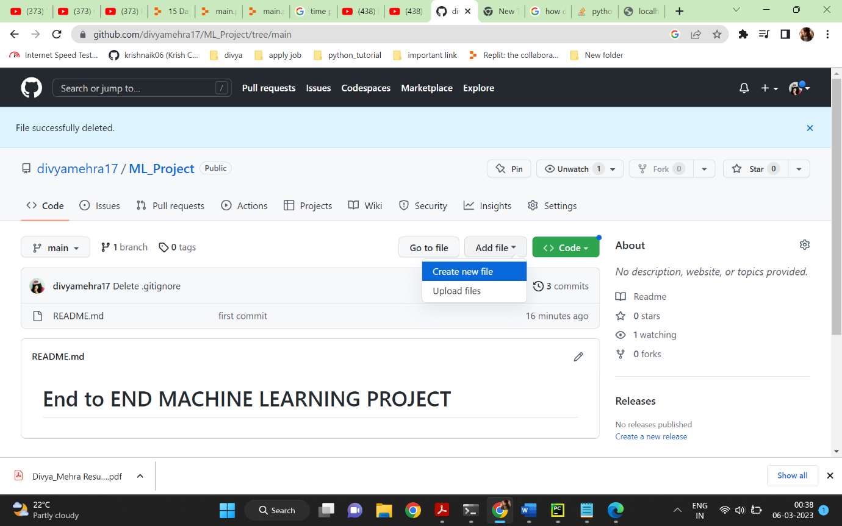

Step2:

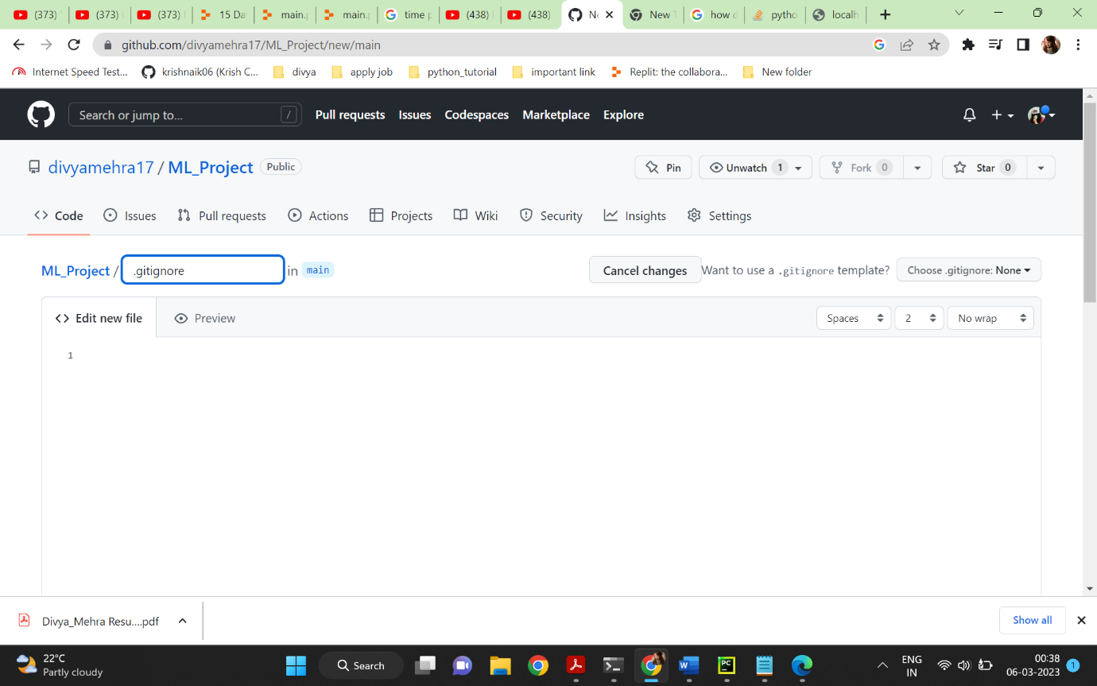

Step3:

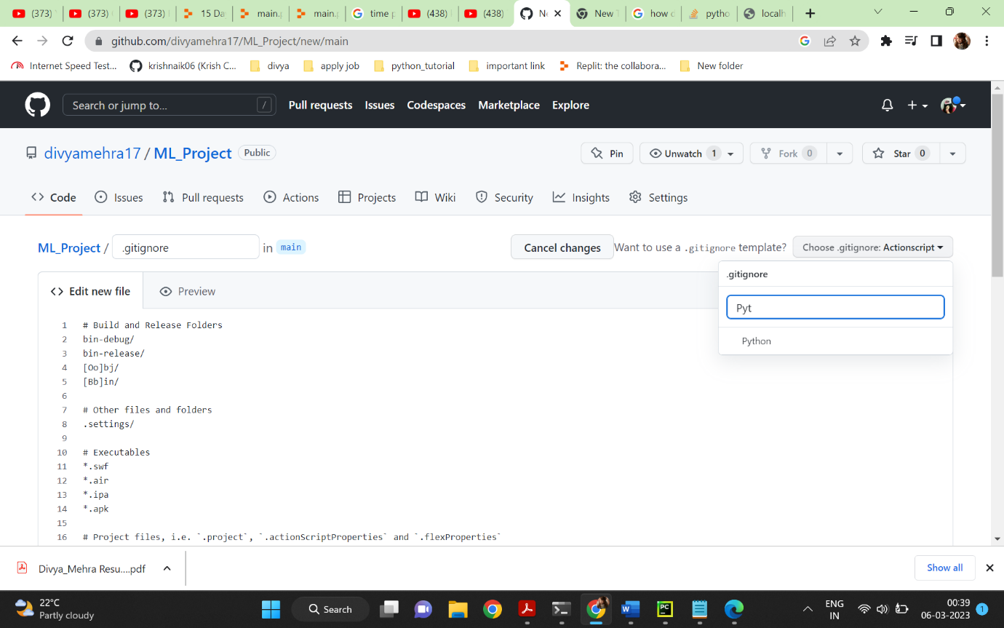

Step4:

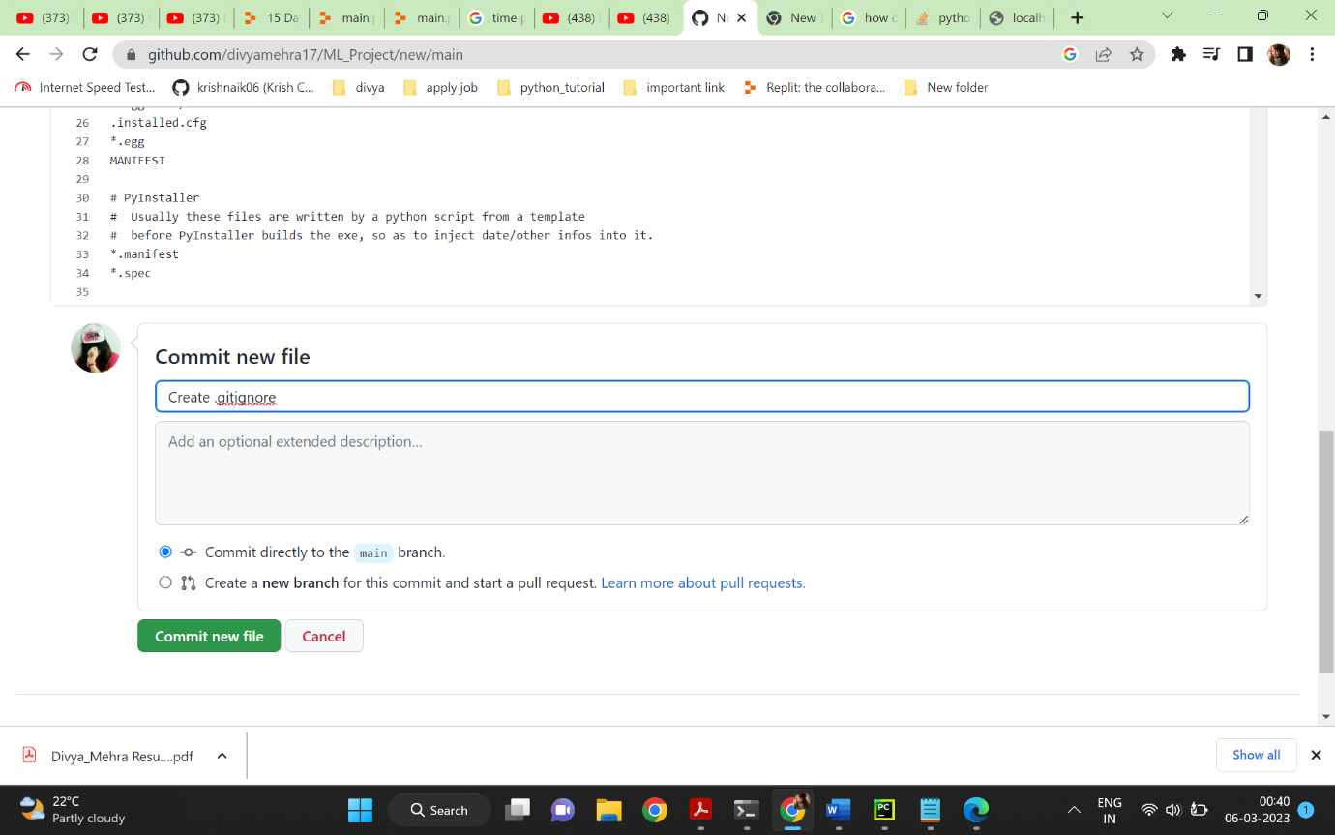

Step5:

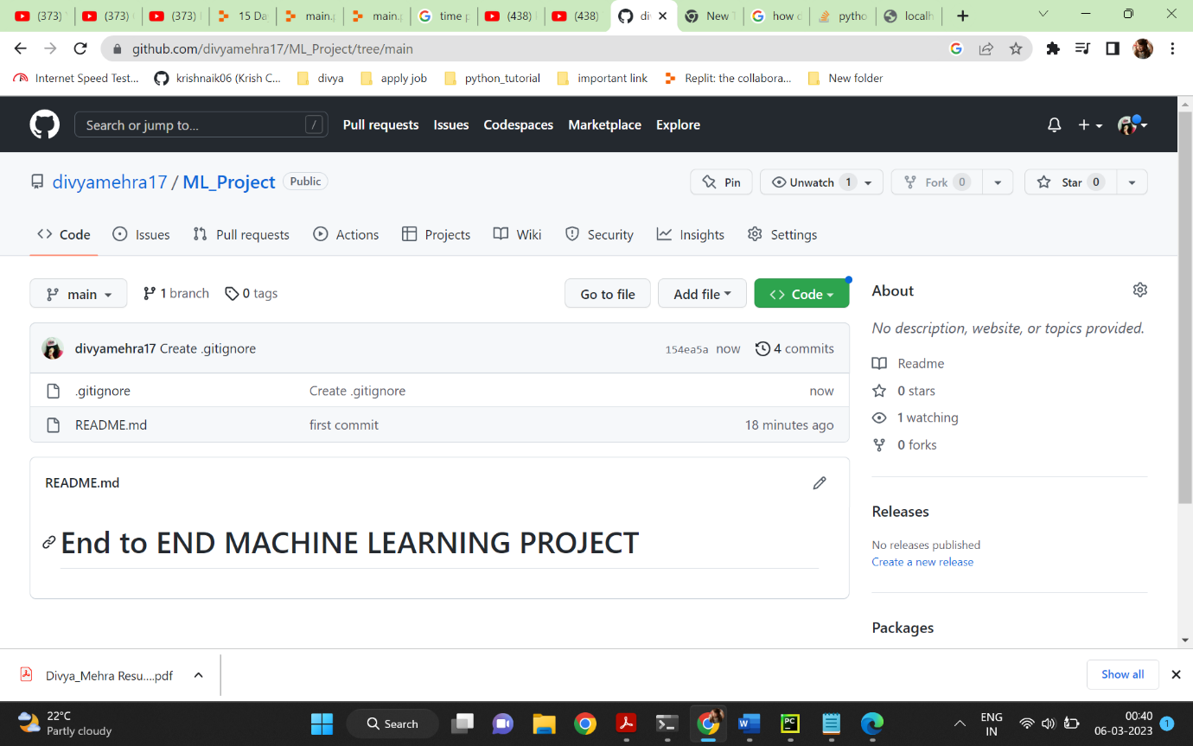

For updation

Step1: PS C:\Users\divya\OneDrive\Desktop\ML_Project> git pull

remote: Enumerating objects: 6, done.

remote: Counting objects: 100% (6/6), done.

remote: Compressing objects: 100% (5/5), done.

remote: Total 5 (delta 0), reused 0 (delta 0), pack-reused 0

Unpacking objects: 100% (5/5), 2.67 KiB | 136.00 KiB/s, done.

From https://github.com/divyamehra17/ML_Project

4f8e350..154ea5a main -> origin/main

Updating 4f8e350..154ea5a

Fast-forward

.gitignore | 129 +++++++++++++++++++++++++++++++++++++++++++++++++++++++++++++

1 file changed, 129 insertions(+)

create mode 100644 .gitignore

# Setup and Requirements.txt

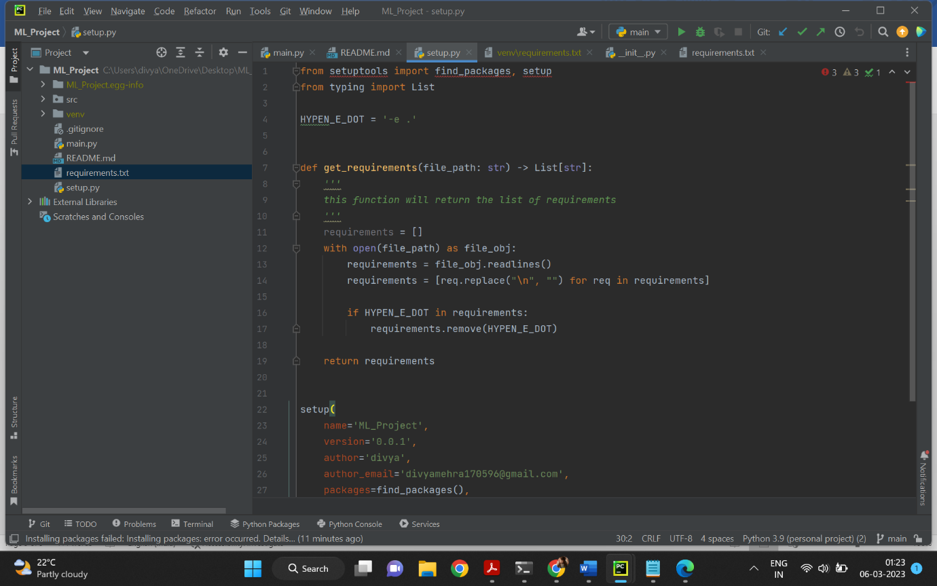

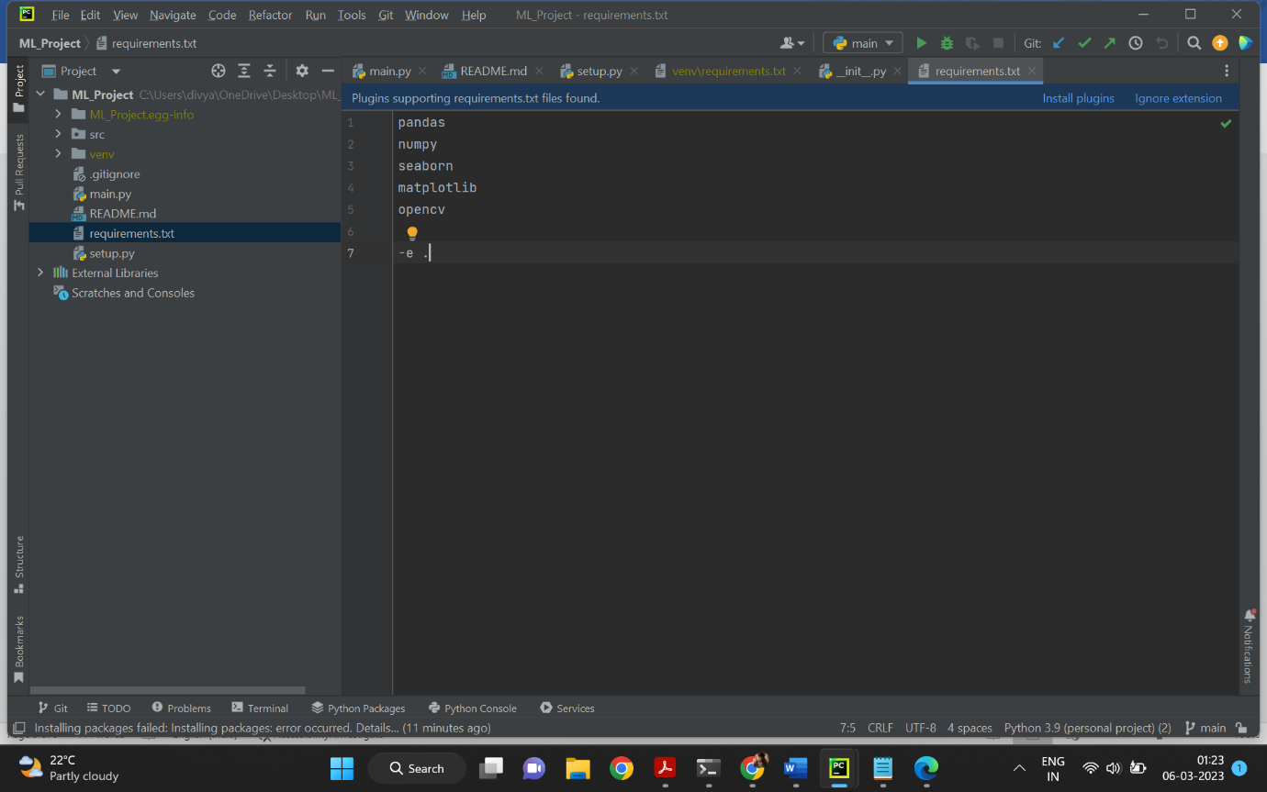

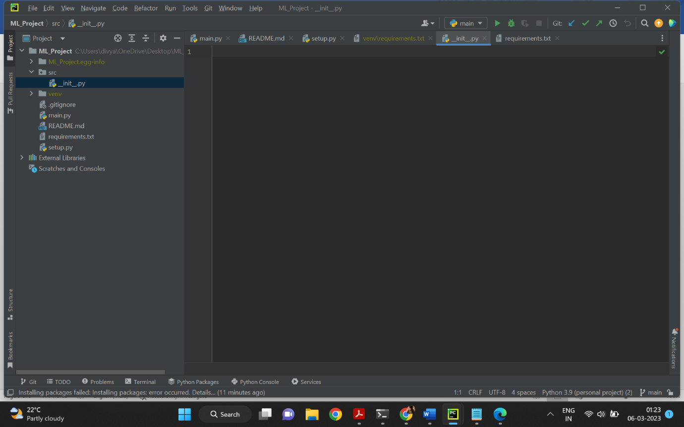

Step1: PS C:\Users\divya\OneDrive\Desktop\ML_Project> pip install -r requirements.txt

Obtaining file:///C:/Users/divya/OneDrive/Desktop/ML_Project (from -r requirements.txt (line 7))

Requirement already satisfied: pandas in c:\users\divya\anaconda3\anaconda\lib\site-packages (from -r requirements.txt (line 1)) (1.0.1)

Requirement already satisfied: numpy in c:\users\divya\anaconda3\anaconda\lib\site-packages (from -r requirements.txt (line 2)) (1.18.1)

Requirement already satisfied: seaborn in c:\users\divya\anaconda3\anaconda\lib\site-packages (from -r requirements.txt (line 3)) (0.10.0)

Requirement already satisfied: matplotlib in c:\users\divya\anaconda3\anaconda\lib\site-packages (from -r requirements.txt (line 4)) (3.1.3)

ERROR: Could not find a version that satisfies the requirement opencv (from -r requirements.txt (line 5)) (from versions: none)

ERROR: No matching distribution found for opencv (from -r requirements.txt (line 5))

PS C:\Users\divya\OneDrive\Desktop\ML_Project> git add.

git: 'add.' is not a git command. See 'git --help'.

The most similar command is

Add

Step2:PS C:\Users\divya\OneDrive\Desktop\ML_Project> git add

Nothing specified, nothing added.

hint: Maybe you wanted to say 'git add .'?

hint: Turn this message off by running

hint: "git config advice.addEmptyPathspec false"

Step3: PS C:\Users\divya\OneDrive\Desktop\ML_Project> git add .

warning: in the working copy of '.idea/inspectionProfiles/Project_Default.xml', LF will be replaced by CRLF the next time Git touches it

warning: in the working copy of '.idea/inspectionProfiles/profiles_settings.xml', LF will be replaced by CRLF the next time Git touches it

PS C:\Users\divya\OneDrive\Desktop\ML_Project> git status

On branch main

Your branch is up to date with 'origin/main'.

Changes to be committed:

(use "git restore --staged <file>..." to unstage)

new file: .idea/.gitignore

new file: .idea/ML_Project.iml

new file: .idea/inspectionProfiles/Project_Default.xml

new file: .idea/inspectionProfiles/profiles_settings.xml

new file: .idea/misc.xml

new file: .idea/modules.xml

new file: .idea/vcs.xml

new file: main.py

new file: requirements.txt

new file: setup.py

new file: src/__init__.py

Step4: PS C:\Users\divya\OneDrive\Desktop\ML_Project> git commit -m "Second commit"

[main e8f08bc] Second commit

11 files changed, 209 insertions(+)

create mode 100644 .idea/.gitignore

create mode 100644 .idea/ML_Project.iml

create mode 100644 .idea/inspectionProfiles/Project_Default.xml

create mode 100644 .idea/inspectionProfiles/profiles_settings.xml

create mode 100644 .idea/misc.xml

create mode 100644 .idea/modules.xml

create mode 100644 .idea/vcs.xml

create mode 100644 main.py

create mode 100644 requirements.txt

create mode 100644 setup.py

create mode 100644 src/__init__.py

PS C:\Users\divya\OneDrive\Desktop\ML_Project> git push -u origin main

Enumerating objects: 17, done.

Counting objects: 100% (17/17), done.

Delta compression using up to 12 threads

Compressing objects: 100% (12/12), done.

Writing objects: 100% (16/16), 3.70 KiB | 1.23 MiB/s, done.

Total 16 (delta 0), reused 0 (delta 0), pack-reused 0

To https://github.com/divyamehra17/ML_Project.git

154ea5a..e8f08bc main -> main

branch 'main' set up to track 'origin/main'.